* **Lab Task 4:**

Display the airport codes that have no routes originating or ending at them.

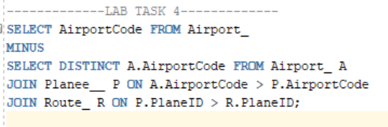

OUTPUT:

